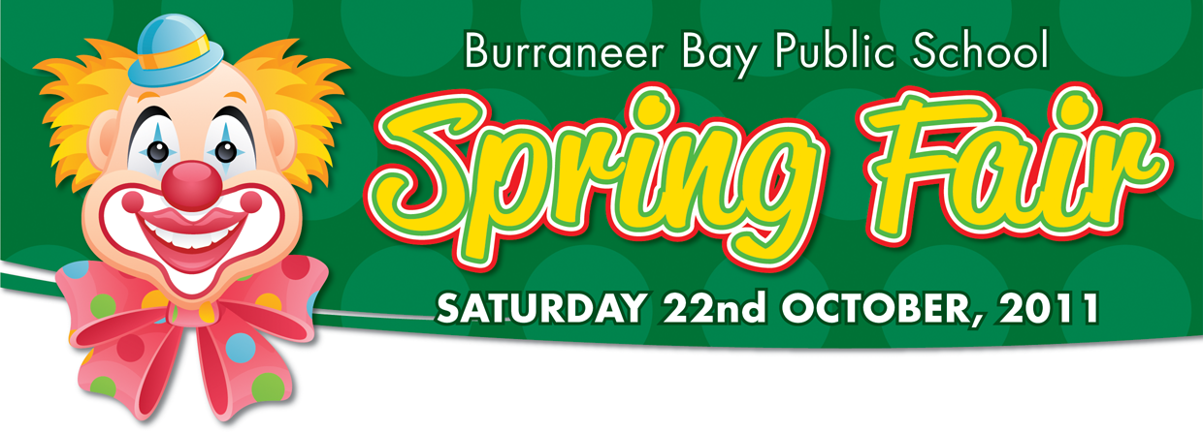
DON’T MISS OUT
Our first online silent auction
Register now to receive exclusive offers
Shop for Kids Sake

www.bbpsauction.hostzi.com
Most items ‘buy it now’ so get in early
Here are a few of the 100’s of items you will find!!
  Brett Kimmorley | 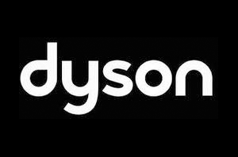  Dyson Vacumn as seen on TV | Signed Jersey  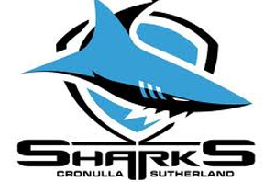
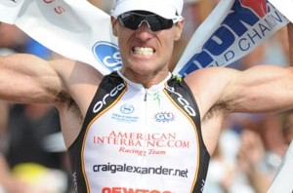  Craig Alexander | 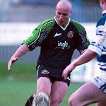  Aaron Raper | 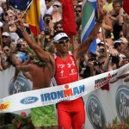  Chris McCormack
  Signed Jersey   | Kids party    How about a MASSAGE? | 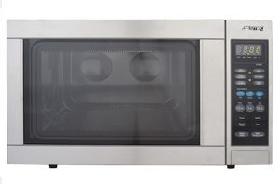 SMEG 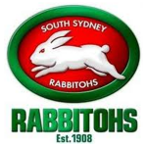Signed Jersey
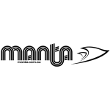  Elino surfboard for sale    Do you have a will?   | 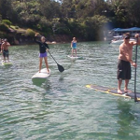  Stand up paddle boarding    Tickets at bargain prices |   Ultimate pamper package  
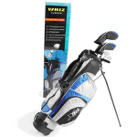 |   Penrith Whitewater Rafting  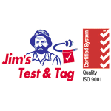 | 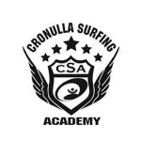
Bidding HAS STARTED DON’T MISS OUT ON THE BARGAINS!!!!!!
Online Bidding closes: 7 pm Thursday 20th October 2011 & will recommence at the spring fair.
Visit: www.bbpsauction.hostzi.com

Get in early for Christmas, birthdays and Gifts. There are plenty of bargains so first in first served. The Successful bidder will receive a confirmation email and arrangement will be made for pickup. Some items up to 80% off.

Thanks to our Web Designer:



