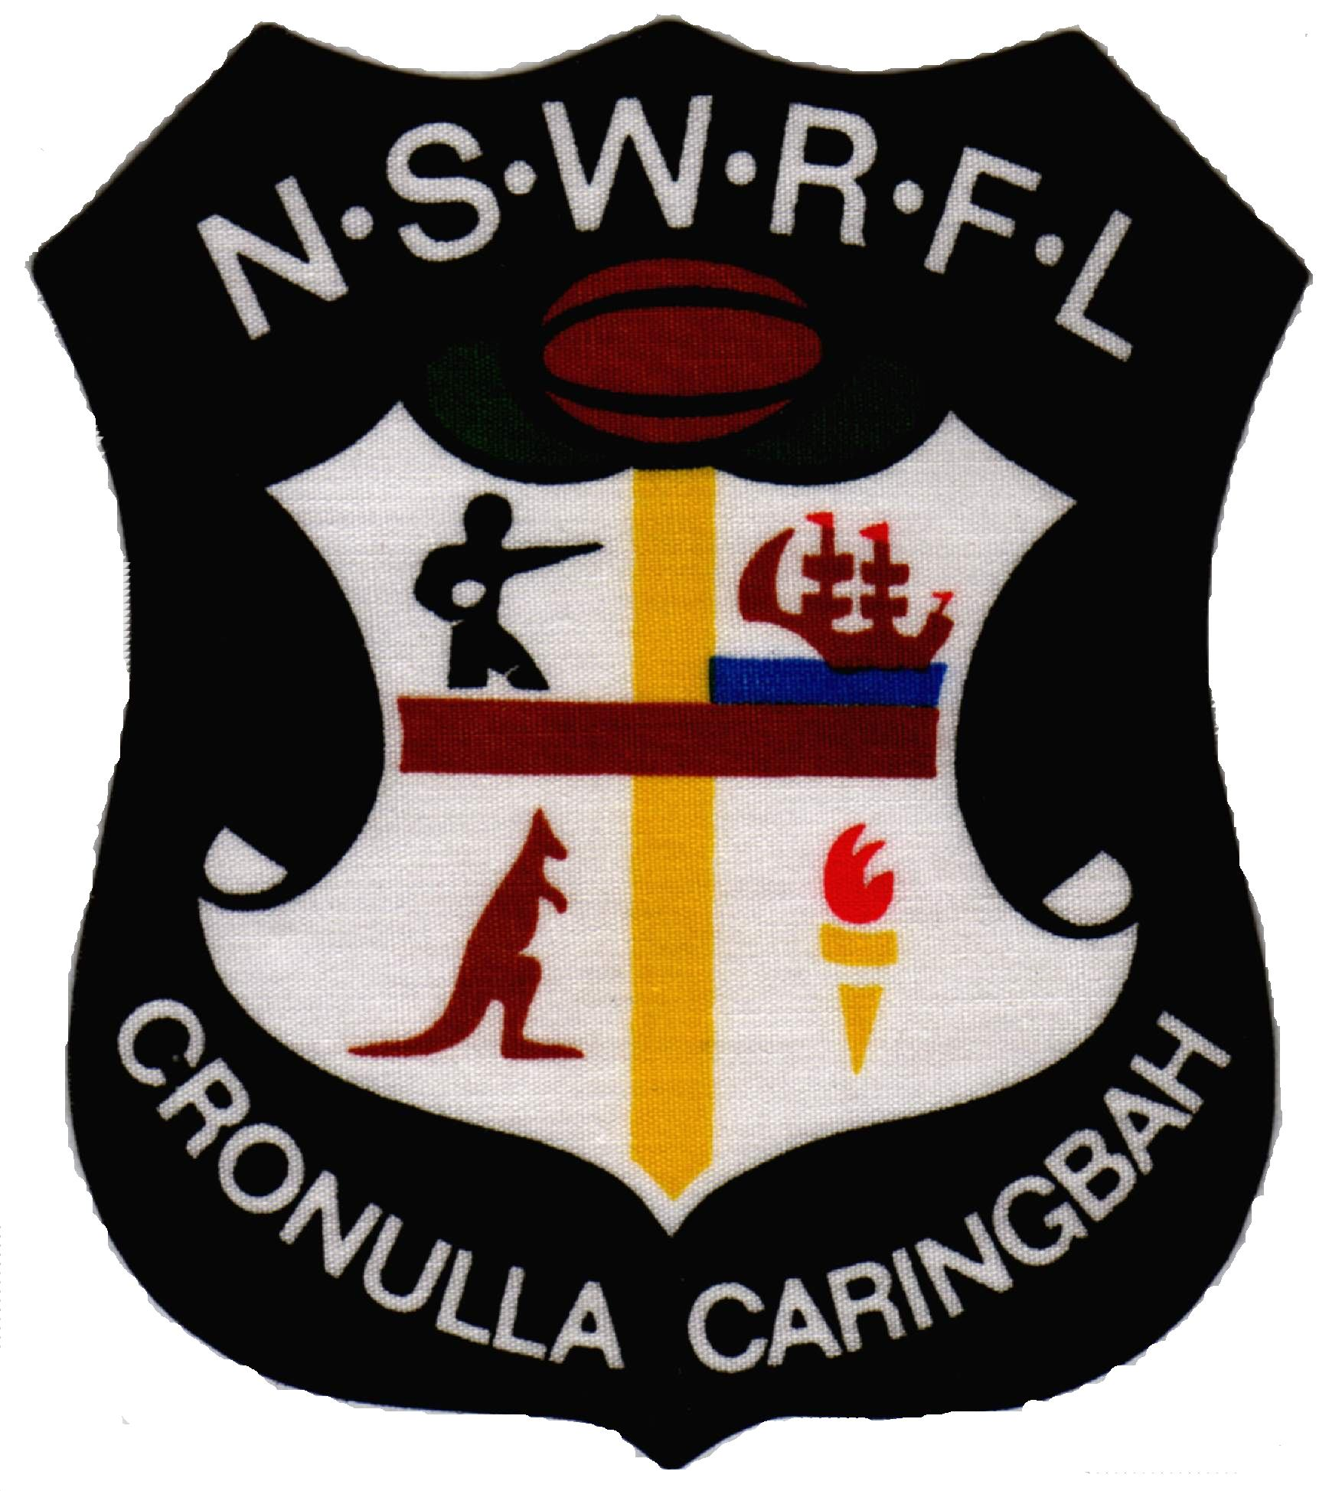


Dear Sir/ Madam

I am writing to you on behalf of the Cronulla Caringbah Junior Rugby League Football Club. Cronulla Caringbah has now officially been accepted into the NSWRL 2008 Jim Beam Cup Competition.

The Jim Beam Cup Competition is managed by the NSWRL and is the 2nd tier competition under the NRL for Rugby League in NSW. Teams competing in this competition, generally have large leagues clubs supporting them, such as Wentworthville Leagues, Mounties and others.

Our District for so many years has been unable to secure a position in this competition due to its financial backing. This has lead to most of the football talent in the shire leave our local Junior League competitions to join other Jim Beam Cup teams.

We are proud that Cronulla Caringbah has been able to successfully enter a team in to this competition with an enormous amount of work thus far. We will be holding a number of events through out next year to secure income, as to operate a team in this competition will take some $250,000.

We have also budgeted for a large sponsorship and donation program and I write to you to ask for your support. We intend to attract local business in the shire to help support this team, as this team will represent the shire. We also have on offer a 200 club, which will give supporters the opportunity to donate $250 to become and inaugural Foundation member of this team. For the $250 donation, you will receive a specially design polo shirt and cap in the team’s colours. Your name will also be added to our website under the foundation members listing. The team will also play out of Toyota Stadium the home of the Cronulla Sutherland Sharks.

As this will be our inaugural year there is huge excitement surrounding this team and we believe it would be a great opportunity for you to become involved in supporting this team.

Please do not hesitate to contact me on 0413511090 to arrange an appointment to discuss this further.

Yours in Sport

Peter Malone
Football Manager

